**NAME – RAKSHIT TIWARI**

**ROLL NUMBER – 160123032**

**LAB 01**

**Q1 The distribution can be checked by running the script present in the same folder. Picture present below highlights the results that we obtained for count up to 10.**

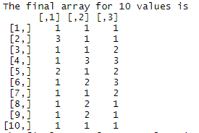

**The error that we obtained is as follows:**

